**AI BASED DESIGN OF FREQUENCY SELECTIVE SURFACE (FSS)**

**A report submitted in partial fulfilment of the requirements for**

**the award of the degree of**

**Bachelor of Technology**

**in**

**Department of Electronics and Communication Engineering**

**By**

**KAPA ADHEESHWAR REDDY (EC21B1023)**

**SADHU POORNA SAI (EC21B1043)**

**SANAPALA CHANDRA SEKHAR (EC21B1044)**



**DEPARTMENT OF**

**ELECTRONICS AND COMMUNICATION ENGINEERING**

**NATIONAL INSTITUTE OF TECHNOLOGY PUDUCHERRY**

**KARAIKAL – 609 609**

**MAY 2025**

**BONAFIDE CERTIFICATE**

**This is to certify that the project work entitled “AI Based Design of Frequency Selective Surface (FSS)” is a Bonafide record of the work done by**

**KAPA ADHEESHWAR REDDY(EC21B1023)**

**SADHU POORNA SAI (EC21B1043)**

**SANAPALA CHANDRA SEKHAR (EC21B1044)**

**in partial fulfilment of the requirements for the award of the degree of Bachelor of Technology in Electronics and Communication Engineering of the NATIONAL INSTITUTE OF TECHNOLOGY PUDUCHERRY during the year 2024 - 2025.**

**Dr. Boopathi Rani R Dr. Boopathi Rani R**

**Assistant Professor Head of Department**

**Project Guide**

**Project viva-voce held on 8th MAY 2024**

**Internal Examiner External Examiner**

**ABSTRACT**

The design of Frequency Selective Surfaces (FSS) plays a vital role in enhancing electromagnetic applications such as radar, wireless communication, and electromagnetic interference (EMI) shielding. Traditional design methods are often repetitive, time-consuming, and lack adaptability. This project presents an AI-based approach for the efficient design and optimization of Stop Band FSS structures, leveraging a novel Forward Prediction Network (FPN) alongside hybrid optimization techniques.

We introduce a new FSS geometry consisting of a hexagonal substrate and a six-legged Swastik-shaped conductive strip. The design is parameterized by two key inputs: the leg length and strip thickness of the conducting element, with the target output being the S21 transmission coefficient. The objective is to identify parameter configurations that effectively achieve stop band behaviour characterized by high signal attenuation within a specific frequency range.

To preprocess the simulation data, spline interpolation is applied to generate smooth and high-resolution frequency response curves. The FPN is trained using a custom loss function to accurately predict the S21 values based on input parameters. Following this, two hybrid optimization strategies are employed to determine optimal design configurations:

(1) Genetic Algorithm combined with Simulated Annealing,

(2) Particle Swarm Optimization combined with Simulated Annealing

(3) NSGA-II combined with Simulated Annealing

These techniques exploit the strengths of both global and local search to converge toward parameter sets that achieve desired stop band characteristics.

By integrating advanced prediction and optimization into the FSS design process, this AI-driven methodology significantly accelerates development while improving accuracy and scalability. It represents a substantial advancement over conventional trial-and-error methods, specifically tailored for high-performance Stop Band FSS applications.

***Keywords:*** Frequency Selective Surfaces (FSS), S21 Transmission Coefficient, Adam Optimizer, Forward Prediction Network (FPN), Improved Particle Swarm Optimization (IPSO), Mean Squared Error (MSE)

**ACKNOWLEDGEMENT**

We are grateful to thank our **Director, Dr. Makarand Madhao Ghangrekar,** for his motivation and providing us necessary infrastructure for doing the project work.

We express our sincere and heartful gratitude to our **Guide,** **Dr. Boopathi Rani R, Department of ECE** for her guidance and supervision at all levels of our project work.

We express our sincerest thanks to our project coordinator **Dr. Aniruddha Kanhe, Assistant Professor, Department of ECE** for his motivation in project reviews.

We express our profound sense of gratitude to our **Head of the department, Dr. Boopathi Rani R** for her encouragement and whose unflagging zeal has catalysed us to strive for greater heights during the span of our course at the **National Institute of Technology Puducherry.**

We thank our beloved **Faculty and Staff members of the ECE Department** for their kind cooperation and encouragement during our project.

We thank our parents and friends who constantly supported us and helped us to complete the project.

**TABLE OF CONTENTS**

|  |  |  |
| --- | --- | --- |
| **CHAPTER NO** | **TITLE** | **PAGE NO** |
|  | ABSTRACT  ACKNOWLEDGEMENT  TABLE OF CONTENTS  LIST OF FIGURES  LIST OF ABBREVIATIONS  LIST OF TABLES | 3  4  5  8  9  10 |
| 1 | INTRODUCTION   * 1. General Introduction   2. Objectives of the thesis | 11  12 |
| 2 | LITERATURE REVIEW  2.1 Frequency Selective Surfaces (FSS) and Design Challenges  2.2 Machine Learning in Electromagnetic Design  2.3 Forward Prediction Networks (FPN) for Fast Parameter Mapping  2.4 Hybrid Optimization Techniques in FSS Design  2.5 AI-Based Design Methodologies and Comparative Efficiency  2.6 Gaps and Future Directions | 13  13  13  13  14  14 |
| 3 | PROPOSED METHODOLOGY  3.1 Overview of the Methodology  3.2 Forward Prediction Network (FPN)  3.3 Optimization Algorithms  3.3.1 Genetic Algorithm with Simulated Annealing (GA+SA)  3.3.2 Particle Swarm Optimization with Simulated Annealing (PSO+SA)  3.3.3 NSGA-II with Simulated Annealing (NSGA-II+SA)  3.4 Integration of FPN with Optimization Algorithms for FSS Design  Optimization  3.5 Simulation and Validation of Optimal Design | 15  16  17  18  18  19  20 |
| 4 | PHASE 1: DESIGNING THE FREQUENCY SELECTIVE SURFACE(FSS)  4.1 Introduction  4.2 Objective of the Phase  4.3 Image of the Designed Model in HFSS  4.4 Description of the Final Model  4.5 Working Mechanism of the FSS  4.6 Design Parameters, Ranges, and Data Collection  4.7 Results and Visualization  4.8 Applications of the Designed FSS  4.9 Summary | 21  21  22  22  23  24  26  26  27 |
| 5 | PHASE 2: NEURAL NETWORK BASED PREDICTION AND HYBRID OPTIMIZATION USING GENETIC ALGORITHM AND SIMULATED ANNEALING  5.1 Introduction  5.2 Methodology  5.3 Neural Network Model Design  5.3.1 Data Processing  5.3.2 Forward Prediction Networks  5.4 Hybrid Optimization Technique  5.5 Working of Model  5.6 Results and Analysis  5.7 Summary | 28  28  28  29  29  30  31  33 |
| 6 | PHASE 3: Enhanced Optimization with PSO+SA and NSGA-II+SA  6.1 Introduction  6.2 Methodology Overview  6.3 Algorithm Descriptions  6.3.1 Particle Swarm Optimization (PSO)  6.3.2 Non-dominated Sorting Genetic Algorithm II (NSGA-II)  6.3.3 Simulated Annealing (SA)  6.4 Working Process of Hybrid Techniques  6.4.1 PSO + SA Framework  6.4.2 NSGA-II + SA Framework  6.5 Results and Visualization  6.5.1 PSO + SA Results  6.5.2 NSGA-II + SA Results  6.6 Summary | 34  34  35  35  35  36  36  36  38  39 |
| 7 | CONCLUSION  7.1 Summary  7.2 Conclusion  7.3 Directions for future work | 40  41  42 |
|  | REFERENCES | 43 |

**LIST OF FIGURES**

|  |  |  |
| --- | --- | --- |
| **Figure No.** | **Title** | **Page No** |
| 3.1 | Flow chart of the proposed method | 15 |
| 4.1 | Hexagonal FSS with Hexagon substrate and Hex-Swastik Conduction Strip | 22 |
| 4.2 | Simulation Visualization of FSS Analysis | 26 |
| 5.1  5.2 | Training Results of the Neural Network (FPN)  Training vs Validation Loss Visualization | 31  31 |
| 5.3 | Results of the GA + SA Optimization | 32 |
| 5.4  5.5 | Visualization of S21 values Optimized Parameters by GA+SA  Simulated S21 Plot of Optimized Parameters | 32  33 |
| 6.1 | Results of the PSO + SA Optimization | 37 |
| 6.2  6.3 | Visualization of S21 values Optimized Parameters by PSO+SA  Simulated S21 Plot of Optimized Parameters | 37  37 |
| 6.4 | Results of the NSGA-II + SA Optimization | 38 |
| 6.5  6.6 | Visualization of S21 values Optimized Parameters by NSGA-II + SA  Simulated S21 Plot of Optimized Parameters | 38  38 |

**LIST OF ABBREVIATIONS**

**FSS** – Frequency Selective Surface

**FPN** – Forward Prediction Network

**IPSO** – Improved Particle Swarm Optimization

**PSO** – Particle Swarm Optimization

**GA** – Genetic Algorithm

**SA** – Simulated Annealing

**NSGA-II** – Non-dominated Sorting Genetic Algorithm II

**S21** – Transmission Coefficient (Scattering Parameter)

**ReLU** – Rectified Linear Unit

**HFSS** – High Frequency Structure Simulator

**DL** – Deep Learning

**AI** – Artificial Intelligence

**ML** – Machine Learning

**LIST OF TABLES**

|  |  |  |
| --- | --- | --- |
| **Table No.**  4.1  6.1 | **Title**  Design Parameters and Their Ranges for Swastik-Shaped FSS Structure  Design Parameters and Their Ranges for Swastik-Shaped FSS Structure | **Page No**  25  39 |

**CHAPTER 1**

**INTRODUCTION**

* 1. **GENERAL INTRODUCTION**

Frequency Selective Surfaces (FSS) are periodic structures engineered to either transmit or block electromagnetic waves at specific frequencies. These structures have gained significant attention due to their diverse applications in antennas, electromagnetic shielding, radomes, stealth technology, and wireless communication systems. Among the various types, **Stop Band FSS** are designed to attenuate signals within a particular frequency range, making them particularly useful in blocking unwanted interference and enhancing system performance.

Traditional FSS design methods are largely reliant on empirical formulas, full-wave electromagnetic simulations, and iterative trial-and-error processes. While effective, these methods are often time-consuming, computationally expensive, and lack adaptability, especially when dealing with complex geometries or multi-parameter optimization.

To overcome these limitations, Artificial Intelligence (AI) has emerged as a powerful tool in accelerating the design and optimization of FSS. This project introduces an **AI-based design framework specifically for Stop Band FSS**, aiming to predict and optimize the transmission response (S21 in dB) using a data-driven approach. A novel FSS structure featuring a **hexagonal substrate and six-legged Swastik-shaped conduction strip** has been developed. The design is defined by two key parameters: **leg length** and **strip thickness**.

By leveraging machine learning techniques—particularly a **Forward Prediction Network (FPN)** with a **custom loss function**—and combining it with three **hybrid optimization algorithms**, this project proposes a fast, accurate, and scalable alternative to traditional FSS design methodologies.

* 1. **Objectives of thesis**
* **Develop an AI-based design framework** for Stop Band Frequency Selective Surfaces (FSS) with applications in radomes, EMI shielding, and communication systems, using a novel hexagonal substrate and six-legged Swastik-shaped conductive structure.
* **Design and train a Forward Prediction Network (FPN)** to accurately predict the transmission coefficient (S21 in dB) based on design parameters such as leg length and strip thickness, thereby reducing dependency on repeated full-wave simulations.
* **Implement a hybrid optimization approach using Genetic Algorithm (GA) combined with Simulated Annealing (SA)** to effectively explore and refine FSS design parameters for achieving the desired stop band characteristics.
* **Apply Particle Swarm Optimization (PSO) integrated with Simulated Annealing (SA)** as an alternative hybrid method to identify optimal structural parameters, leveraging both global and local search capabilities for stop band FSS optimization.
* **Integrate NSGA-II with Simulated Annealing (NSGA-II + SA**) for multi-objective optimization, offering improved trade-off control between stop band depth and bandwidth
* **Reduce computational cost and design time** significantly by replacing iterative simulation-based design workflows with a predictive-optimization AI model.
* **Demonstrate high accuracy and generalization ability** of the AI model for complex FSS geometries, validating its potential as a scalable and efficient alternative to conventional FSS design methods.

**CHAPTER 2**

**LITERATURE REVIEW**

**2.1. Frequency Selective Surfaces (FSS) and Design Challenges**

Frequency Selective Surfaces (FSS) function as spatial filters and are vital in applications such as radomes, EMI shielding, and wireless communication systems. Traditional FSS design relies on iterative full-wave electromagnetic simulations, which, although accurate, are computationally expensive and time-consuming—especially when dealing with complex and novel topologies.

The electromagnetic behaviour of FSS structures is highly sensitive to geometrical parameters, polarization, and incidence angles, complicating the task of meeting specific transmission or reflection goals. These challenges underline the necessity of AI-driven methods that can accelerate the design process without compromising accuracy.

**2.2. Machine Learning in Electromagnetic Design**

Machine learning, especially deep learning, has proven effective in electromagnetic design by learning the relationship between geometric parameters and responses like S-parameters from simulation data. Neural network models—such as fully connected networks, CNNs, and RNNs—enable fast, accurate forward predictions for meta surfaces and FSS, eliminating the need for repeated simulations. Despite their advantages, challenges persist in generalization across designs, accuracy at boundary frequencies, and inverse design capabilities.

**2.3. Forward Prediction Networks (FPN) for Fast Parameter Mapping**

In this work, a **Forward Prediction Network (FPN)** based on a fully connected neural network is employed to predict the transmission coefficient (S21 in dB) of a novel Stop Band FSS structure. Unlike previous models, this FPN is trained using a **custom loss function** tailored to prioritize accuracy around the stop band region.

To prepare the dataset, **Min-Max Scaler** is used as a preprocessing step to normalize the input parameters, ensuring efficient training and improved convergence. The trained FPN demonstrates high accuracy across a wide frequency range, providing immediate and reliable predictions for various design inputs such as leg length and strip thickness.

**2.4. Hybrid Optimization Techniques in FSS Design**

While traditional optimization algorithms like Genetic Algorithm (GA) and Particle Swarm Optimization (PSO) are widely used in FSS tuning, they often face limitations like premature convergence or high computational cost.  
To overcome this, the present work introduces three hybrid optimization approaches:

* **GA + Simulated Annealing (GA + SA):** GA efficiently explores the global search space, while SA helps refine solutions by escaping local minima.
* **PSO + Simulated Annealing (PSO + SA):** PSO accelerates convergence using swarm intelligence, while SA ensures solution robustness through probabilistic jumps in the design space.
* **NSGA-II + Simulated Annealing (NSGA-II + SA):** NSGA-II, a multi-objective evolutionary algorithm, enables simultaneous optimization of multiple performance metrics, and SA further improves diversity and convergence toward optimal fronts.

All three methods are used to optimize the structural parameters predicted by the FPN to meet specific stop band performance criteria. These hybrid approaches effectively balance global exploration and local exploitation, yielding superior optimization results compared to conventional methods.

**2.5. AI-Based Design Framework and Performance Efficiency**

Combining the Forward Prediction Network (FPN) with hybrid optimization techniques enables a fast and accurate FSS design framework, achieving up to 99% improvement in efficiency over traditional simulation-based methods while maintaining high design accuracy. The integrated approach ensures transmission coefficient errors remain within 1 dB of target values, with minimal deviation in center frequency and bandwidth. It significantly reduces design time, limits the need for repeated simulations, and enhances parameter tuning precision. Experimental results validate the effectiveness of all three hybrid strategies GA + SA, PSO + SA, and NSGA-II + SA each offering unique strengths depending on design complexity and multi-objective stop band optimization needs.

**2.6. Gaps and Future Directions**

Despite the improvements in forward prediction and hybrid optimization, challenges remain in extending these models for **inverse design** where the objective is to predict geometric parameters from a desired S21 response. Furthermore, current FPN models are trained for specific FSS structures; creating **generalized models** that adapt to different topologies without retraining would be a valuable advancement.

**CHAPTER 3**

**Proposed Methodology**

**3.1. Overview of the Methodology**

The proposed methodology integrates a deep learning-based Forward Prediction Network (FPN) with three advanced hybrid optimization strategies GA+SA, PSO+SA, and NSGA-II+SA to optimize the structural parameters of a Frequency Selective Surface (FSS). The FPN serves as a fast surrogate model that predicts the S21 transmission coefficient for given FSS parameters, eliminating the need for repeated electromagnetic simulations. Each hybrid optimization approach explores the parameter space in its own way—Genetic Algorithm focuses on evolutionary operations, PSO mimics swarm intelligence, and NSGA-II handles multi-objective optimization. These are each refined using Simulated Annealing to ensure convergence to high-quality solutions. This combination provides flexible, accurate, and computationally efficient FSS design across different performance criteria.

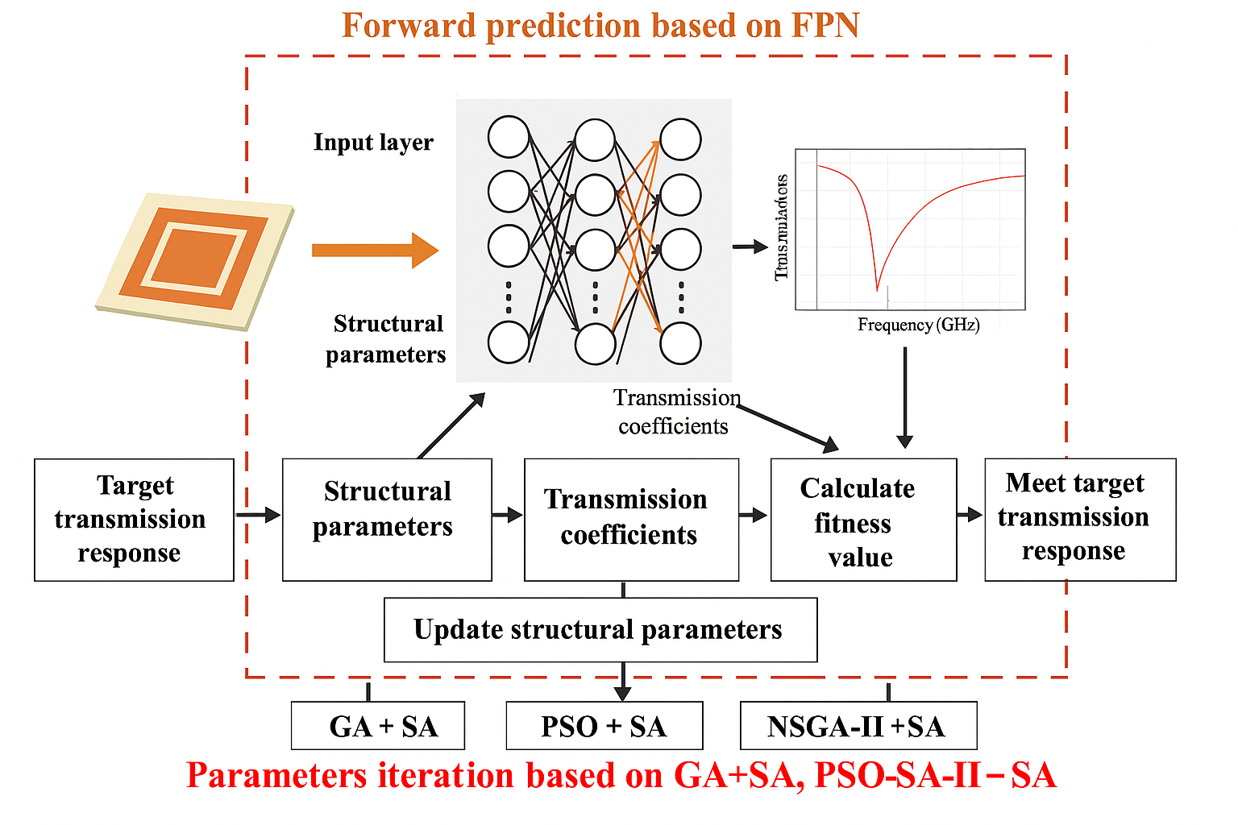

Fig (3.1) Flow chart of the proposed method

**3.2. Forward Prediction Network (FPN)**

* Purpose and Role of FPN:
  + In conventional FSS design, each design iteration typically requires electromagnetic simulation, which is computationally expensive. To overcome this, a Forward Prediction Network (FPN) a deep learning model is used as a surrogate. It learns to predict the transmission coefficient (S21) across the frequency spectrum based on structural parameters (length *l*, width *t*, and frequency), thereby significantly accelerating the optimization process by eliminating the need for repeated simulations.
* Data Acquisition:
  + To train the FPN, a substantial dataset representing diverse FSS structures and their frequency responses is generated. Using electromagnetic simulation software (such as HFSS), each FSS structure is simulated to produce transmission data, covering a range of frequencies.
  + The FSS structure is parameterized, with some dimensions and material properties fixed to maintain structural consistency, while other critical parameters are varied within defined ranges. These adjustable parameters (like loop and patch dimensions) affect the FSS response and thus form the basis for optimization.
  + Thousands of data samples are generated, each consisting of an input vector of structural parameters and an output transmission coefficient curve. The frequency response data captures the curve across a set frequency range, with each data point representing the magnitude of the transmission coefficient at a specific frequency.
* Network Architecture and Configuration:
  + A fully connected feedforward neural network (FPN) is used to approximate the mapping between FSS structural parameters and the corresponding S21 transmission values. The input layer receives three features—*l*, *t*, and *frequency*. This is followed by multiple dense hidden layers, all using ReLU activation functions. A dropout layer with a 30% rate is added to prevent overfitting and improve generalization. The final output layer uses a linear activation to produce the S21 value.
  + Hyperparameters include the Adam optimizer (with a small learning rate of 5e-5) and a custom weighted loss function, which assigns greater penalties to large prediction errors using exponential weighting. This improves the network’s sensitivity to critical deviations. Early stopping and learning rate reduction callbacks are also integrated to stabilize training and ensure convergence without overfitting
* Training and Validation:
  + The dataset is split into training, validation, and testing sets to assess model performance and prevent overfitting. After training, the network’s predictions are compared to simulated values from the electromagnetic software.
  + Validation results demonstrate that the trained FPN closely approximates the simulated transmission coefficient curve. This accuracy enables the FPN to be a reliable surrogate for direct simulation, accelerating the optimization process without sacrificing fidelity.

**3.3. Optimization Algorithms**

**3.3.1 Genetic Algorithm with Simulated Annealing (GA+SA)**

* + **Objective of GA+SA in the FSS Design Process**

The GA+SA approach aims to identify the optimal structural parameters (l, t) for an FSS that results in the desired transmission (S21) characteristics over a target frequency range. The Genetic Algorithm searches broadly across the design space, while Simulated Annealing refines the best candidate solution found by GA to enhance convergence accuracy.

* + **Basic Genetic Algorithm Mechanism**

GA begins with a population of randomly generated individuals, where each individual represents a potential FSS configuration. Through iterative cycles of selection, crossover, and mutation, the population evolves. Selection chooses the fittest individuals, crossover mixes their attributes, and mutation introduces slight variations. This mimics natural evolution and guides the population toward better solutions.

* + **Integration of Simulated Annealing (SA)**

Once GA identifies the best individual (solution), SA takes over to perform local refinement. SA explores nearby solutions by accepting changes that may initially worsen performance, allowing it to escape local optima. Over time, the probability of accepting worse solutions decreases (via a cooling schedule), leading to stable convergence on a global optimum.

**3.3.2 Particle Swarm Optimization with Simulated Annealing (PSO+SA)**

* + **Objective of PSO+SA in the FSS Design Process**

The PSO+SA approach seeks to optimize the physical dimensions of the FSS structure to maximize stop-band suppression while balancing width and depth. PSO provides fast convergence with swarm-based exploration, and SA improves the precision by fine-tuning the best solution.

* + **Basic PSO Mechanism**

PSO initializes a group of particles, where each particle represents a candidate design. Each particle updates its position based on its own best-known position and the swarm's global best-known position. This combination of self-knowledge and social influence helps particles collectively move toward the optimal region in the design space.

* + **Enhancement with Simulated Annealing**

To further refine the global best result obtained from PSO, SA is applied to explore the local neighbourhood around the solution. This helps escape any local minima that PSO may converge to prematurely and enhances the final accuracy of the parameter prediction.

**3.3.3 NSGA-II with Simulated Annealing (NSGA-II+SA)**

* + **Objective of NSGA-II+SA in the FSS Design Process**

The NSGA-II+SA approach addresses multi-objective optimization, targeting both stop-band width and depth simultaneously. NSGA-II efficiently finds a diverse set of trade off (optimal) solutions, and SA selects and refines one of these for final deployment.

* + **Core Mechanism of NSGA-II**

NSGA-II (Non-dominated Sorting Genetic Algorithm II) maintains a population that evolves via selection, crossover, and mutation. Instead of a single objective, it uses Pareto dominance to evaluate solutions and builds a Pareto front of optimal trade-offs. Diversity among solutions is maintained using crowding distance, ensuring broad coverage of the solution space.

* + **Enhancement with Simulated Annealing**

After NSGA-II produces a Pareto front, a preferred solution (e.g., one with maximum width and reasonable depth) is chosen. SA is then used to locally optimize this solution, allowing small refinements that may not be captured in the evolutionary process, thus improving local accuracy without sacrificing the global trade-off.

**3.4 Integration of FPN with Optimization Algorithms for FSS Design**

* Initialization:

Each optimization algorithm (GA+SA, PSO+SA, and NSGA-II+SA) begins by generating a population of candidate FSS designs, each represented by a set of structural parameters (e.g., l and t). Instead of performing costly electromagnetic simulations for every candidate, the trained Forward Prediction Network (FPN) is used to predict the corresponding S21 transmission curve for each set of parameters.

* Fitness Evaluation and Objective Function:

The FPN-predicted S21 values are used to evaluate the fitness of each candidate design. The objective function measures how closely the predicted frequency response matches desired stop-band specifications. Typically, a solution is penalized if it does not maintain S21 below a certain threshold within a frequency band, or if the stop-band is too narrow or shallow. This allows the optimization process to systematically search for parameter combinations that satisfy the design goals.

* Iterative Optimization Process:
  + GA evolves the population using selection, crossover, and mutation.
  + PSO updates particle positions and velocities based on personal and global bests.
  + NSGA-II maintains a Pareto front of solutions, exploring trade-offs between competing objectives. At each step, the FPN acts as a fast surrogate model, replacing full-wave simulation and significantly accelerating fitness evaluations. Once a globally optimal or Pareto-optimal solution is identified, Simulated Annealing (SA) is applied to that candidate for local refinement.
* Optimal Parameter Selection:

After convergence, the best candidate (in terms of the defined fitness function) is selected as the final optimized design. The hybrid structure where global search is handled by GA/PSO/NSGA-II and local fine-tuning by SA results in high precision and efficiency. This integration allows for robust exploration and reliable convergence, even in complex, multi-modal design spaces.

**3.5 Simulation and Validation of Optimal Design**

* Simulation of Optimized Structure:

The optimal structural parameters obtained from the hybrid optimization approaches (GA+SA, PSO+SA, NSGA-II+SA) are used to construct the final FSS model in electromagnetic simulation software. These simulations are conducted to validate the accuracy of the deep learning model’s predictions and confirm that the optimized structure exhibits the desired transmission behaviour.

* Validation Against Target Specifications:

The simulated transmission coefficient curve is compared to the predicted curve from the Forward Prediction Network (FPN). Particular attention is given to ensuring the depth, width, and resonant frequency of the stop band align with target specifications. Any deviations from the expected response are analysed and verified to remain within acceptable design margins.

* Comparison with Traditional Methods:

In comparison to traditional full-wave simulation-based iterative optimization, the use of FPN in combination with metaheuristic optimization significantly reduces computational time. The combined methods provide high accuracy with reduced evaluation overhead. Time taken for each approach to converge to optimal parameters is recorded, demonstrating the practical advantage of the hybrid FPN-guided optimization in accelerating the FSS design process.

**CHAPTER 4**

**PHASE 1: DESIGNING THE FREQUENCY SELECTIVE SURFACE(FSS)**

**4.1 Introduction**

Designing a Frequency Selective Surface (FSS) involves the strategic development  
of periodic structures capable of selectively transmitting or reflecting electromagnetic  
waves based on their frequency, functioning as spatial filters in applications such as  
electromagnetic shielding, radar cross-section reduction, and antenna systems.  
The effectiveness of an FSS depends on the geometry of its unit cell, element arrangement,  
and the choice of substrate and conductive materials.  
In this project, a Swastik-shaped resonator placed within a hexagonal unit cell has been  
selected to achieve a stopband behaviour across a desired frequency range.  
This innovative design is modelled and simulated using ANSYS HFSS to extract transmission characteristics. A series of systematic parametric sweeps are conducted to collect a diverse and informative dataset, which forms the basis for the later application of AI-based modelling and optimization.

**4.2 Objective of the Phase**

The main objective of this phase is to **conceptualize and design an efficient unit cell of a Frequency Selective Surface (FSS)** with enhanced filtering characteristics. The goal is to explore innovative geometric patterns that provide superior electromagnetic behaviour over conventional square or circular patterns.

The specific objectives of this phase are:

* **To create a unique and symmetric design** using a **hexagonal substrate** embedded with a **six-legged Swastik shaped slot**, which is expected to deliver better performance in terms of polarization insensitivity, angular stability, and frequency selectivity.
* **To optimize the layout of the FSS unit cell** for creating sharp stopbands and minimal insertion loss in passbands. The six-armed Swastik structure increases the number of resonance paths, which may enhance the multi-resonant behaviour of the FSS.
* **To ensure suitability for modern high-frequency applications**, such as stealth technologies and EM shielding, where compact and efficient designs are needed to suppress unwanted signals while allowing desired frequencies to pass.
* **To prepare the structure for simulation** in the next phase, ensuring that the dimensions, slot geometry, and materials are selected correctly so that S-parameter (S11 and S21) analysis can be accurately performed.

This phase acts as a **foundation for performance evaluation** in subsequent simulations by defining a design that supports high resonance control and filtering capability in selected frequency bands.

**4.3 Image of the Designed Model in HFSS**

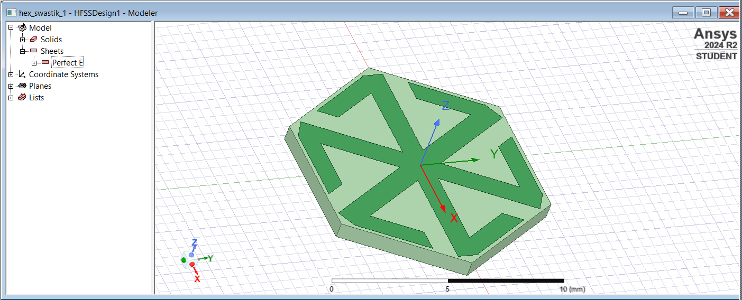

Fig (4.1) Hexagonal FSS with Hexagon substrate and Hex-Swastik Conduction Strip

**4.4 Description of the Final Model**

The final model designed in Phase 1 is a **hexagonal Frequency Selective Surface (FSS)** unit cell with a **six-legged Swastik slot** at its centre. This unique structure combines **hexagonal geometry**, known for high packing efficiency and symmetrical layout, with a **Swastik-shaped etched slot**, designed to create multiple resonances.

**Key Elements of the Final Model:**

* **Substrate Material**: Rogers RO4003C (or equivalent), which offers:
  + Dielectric constant (εr) ≈ 3.38
  + Low dielectric loss
  + Suitable for microwave and RF frequencies
* **Hexagonal Shape**:
  + Each side of the hexagon is equal, offering **rotational symmetry**.
  + Helps maintain consistent response for different polarizations and angles of incidence.
  + Enables **dense packing** for 2D periodic arrays in real-world applications.
* **Swastik-Shaped Slot**:
  + Cut out of the **top copper layer**.
  + Has **six symmetrically placed arms**—three on each axis—making it more balanced than traditional four-arm Swastik slots.
  + These slots act as **resonators**, altering the current path and creating **multiple resonant frequencies**.
  + The geometry of the slot is critical in tuning the stopband frequency.
* **Ground Plane**: May be present or omitted depending on simulation requirement (e.g., for transmission-type FSS, the ground may be removed).
* **Excitation Setup**:
  + Ports and periodic boundary conditions are added in the next phase to simulate the interaction of electromagnetic waves with the unit cell.

The model, as shown in the design image, is now ready for simulation and further evaluation of its filtering behaviour via S-parameter analysis.

**4.5 Working Mechanism of the FSS**

The FSS structure works on the principle of **resonance and periodicity**. When an **incident electromagnetic wave** strikes the periodic array, certain frequencies are either **transmitted** or **reflected**, based on the structure's geometry and material properties.

**Behaviour at Different Frequencies:**

* **At Resonant Frequencies**:
  + The **Swastik slot resonates**, causing destructive interference and energy trapping.
  + This leads to a **sharp decrease in transmission** (S21 → low), forming a **stopband**.
* **At Non-Resonant Frequencies**:
  + The EM wave passes through with minimal loss (S21 → high), forming a **passband**.

**Equivalent Circuit Representation:**

The FSS can be modelled as an **LC resonant circuit**:

* **L (Inductance)** arises from the **current path along the arms** of the Swastik slot.
* **C (Capacitance)** is introduced due to **gaps and spacing** between arms or edges.

The resonant frequency of this LC circuit is given by:

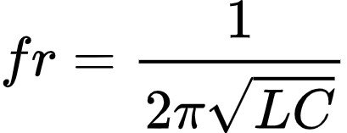

By **modifying the arm lengths, slot width, and spacing**, one can control L and C, thereby adjusting the resonance frequency.

**Effects of Design Parameters:**

* **Number of Arms**: More arms create **multiple current paths**, increasing the number of possible resonances.
* **Slot Length**: Longer slots increase inductance, lowering the resonant frequency.
* **Slot Width**: Wider slots increase capacitance and shift the frequency slightly lower.
* **Symmetry**: Symmetry ensures that the structure behaves similarly for both TE and TM polarizations.

This working mechanism makes the designed FSS suitable for **precise frequency filtering**, especially when multiple resonances are desired in the microwave or milli meter wave ranges.

**4.6 Design Parameters, Ranges, and Data Collection**

To achieve the desired stopband performance in the range of 2 GHz to 16 GHz, the FSS unit cell was carefully designed with specific geometrical and material parameters. The geometry used in this project is a Swastik-shaped conductor embedded within a hexagonal unit cell. The two key design parameters that significantly influence the electromagnetic behaviour are:

* Leg Length (l): This is the distance from the centre of the Swastik to the tip of each arm. It primarily controls the resonant frequency of the unit cell.
* Leg Thickness (t): This refers to the width of each arm of the Swastik, which affects the bandwidth and strength of the stopband.

The selected parameter ranges for the simulation study are as follows:

Table 4.1: Design Parameters and Their Ranges for Swastik-Shaped FSS Structure

|  |  |  |
| --- | --- | --- |
| **Parameter** | **Description** | **Range** |
| l | Length of the Swastik arm | 1.0 mm – 5.8 mm |
| t | Thickness (width) of Swastik legs | 0.2 mm – 1.0 mm |

These ranges were chosen based on preliminary analysis and literature review to cover both narrow and broad resonant behaviours.

The material used for the design is:

* Substrate: Rogers RO4003C (εr ≈ 3.38), known for its low loss at high frequencies.
* Conductor: Copper (σ = 5.8 × 10⁷ S/m), which provides high conductivity for minimal resistive loss.

Data Collection Process

The simulation was carried out using ANSYS HFSS, with the following steps:

1. Design Setup:
   * A single unit cell with periodic boundary conditions was modelled.
   * The Swastik geometry was created with adjustable parameters (l and t).
   * The frequency sweep was set from 2 GHz to 16 GHz.
2. Parametric Sweep:
   * Multiple simulations were run by varying l and t within their defined ranges.
   * For each combination, the S21 (transmission coefficient) was recorded.

This simulation dataset will serve as the foundation for identifying optimal FSS configurations and training predictive models in the next phases of the project.

**4.7 Results and Visualization**

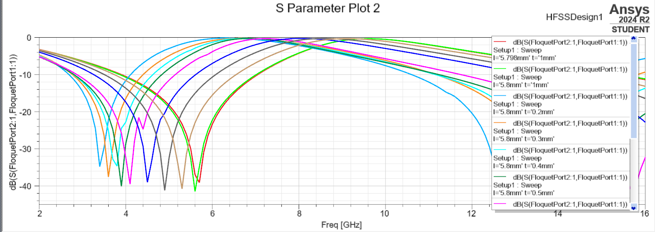

Fig (4.2) Simulation Visualization of FSS Analysis

**4.8 Applications of the Designed FSS**

The proposed Frequency Selective Surface (FSS) design, featuring a Swastik-shaped resonator within a hexagonal unit cell, offers several distinct advantages that make it suitable for a wide range of practical high-frequency applications. The **geometric symmetry** of the Swastik ensures polarization insensitivity, allowing the structure to maintain consistent filtering behaviour regardless of the orientation of the incoming electromagnetic wave. Additionally, the **compact and periodic nature** of the design enables effective miniaturization, which is particularly beneficial for space-constrained systems in modern electronics and defence applications.

The material choice—copper as the conducting element and Rogers RO4003C as the substrate—enhances the design’s **electromagnetic stability** and **low-loss performance** over a wide frequency range. These benefits collectively make the design suitable for the following key applications:

* **Electromagnetic (EM) Shielding**: The stopband characteristics effectively block unwanted RF signals, protecting sensitive circuitry in communication and medical devices.
* **Stealth Technology**: By suppressing specific radar frequency bands, the design helps reduce radar cross-section (RCS), making it ideal for use in military stealth platforms.
* **Antenna Radomes**: The structure can be embedded in radome materials to selectively pass operating frequencies while attenuating interference, improving signal clarity and system reliability.
* **Multiband Communication Systems**: With the ability to define stopbands within a broad frequency range (2 GHz to 16 GHz), this FSS can be used in environments that require filtering of multiple interference bands without affecting desired signals.

Overall, the design’s combination of **frequency-selectivity**, **geometric flexibility**, and **material efficiency** ensures its relevance across various high-performance RF and microwave engineering domains.

**4.9 Summary**

In this chapter, we successfully designed a **hexagonal Swastik-shaped Frequency Selective Surface (FSS)** unit cell using ANSYS HFSS. The choice of geometry ensures high symmetry, polarization insensitivity, and angular stability. The Swastik slot introduces resonance that can be tailored to specific frequencies. The unit cell is now ready for electromagnetic simulation in the next phase, where its transmission characteristics will be analysed in detail.

**CHAPTER 5**

**PHASE 2: NEURAL NETWORK BASED PREDICTION AND HYBRID OPTIMIZATION USING GENETIC ALGORITHM AND SIMULATED ANNEALING**

**5.1 Introduction**

Artificial intelligence techniques are increasingly being used in engineering design to reduce time, improve accuracy, and explore large design spaces efficiently. In Frequency Selective Surface (FSS) design, electromagnetic simulation tools like ANSYS HFSS are traditionally used to evaluate transmission performance. However, repeated simulations for parametric variations can be time-consuming. To address this, a neural network is employed to predict the transmission coefficient (S21) using geometric parameters and frequency as inputs. Additionally, a hybrid optimization technique combining Genetic Algorithm and Simulated Annealing is introduced to determine the optimal design configuration that yields desirable stopband performance.

**5.2 Methodology**

This phase involves two key tasks: predictive modelling and parameter optimization. First, a Feedforward Neural Network is developed to learn the complex relationship between frequency, structural dimensions (length and thickness of the Swastik arms), and the S21 parameter. The model is trained using simulation data generated through systematic parametric sweeps in ANSYS HFSS.

Once the model is validated, it replaces the simulation tool for fast evaluations. For optimization, a hybrid method that merges the global search capability of the Genetic Algorithm with the local refinement ability of Simulated Annealing is implemented. This allows for an effective exploration and exploitation of the design space to identify the best possible FSS configuration.

**5.3 Neural Network Model Design**

**5.3.1 Data Processing**

Before training the neural network, the simulation data comprising parameters like Swastik arm length, thickness, and corresponding S21 values is pre-processed to ensure consistency and reliability. Any missing or noisy data is cleaned, and feature scaling (such as normalization) is applied to bring all inputs into a comparable range. The dataset is then split into training, validation, and test sets to ensure robust model evaluation. This preprocessing step helps improve learning efficiency, prevents overfitting, and ensures the model generalizes well to new data.

**5.3.2 Forward Prediction Network**

The neural network used for prediction is a standard Feedforward Neural Network architecture, trained in a supervised manner. It consists of:

* Input Layer: 3 neurons (representing Frequency, Arm Length, Arm Thickness)
* Hidden Layers: Two layers with ReLU activation functions
* Output Layer: 1 neuron representing the predicted S21 value

**Custom Loss Function**

To improve the network’s sensitivity to larger prediction errors and to enhance the precision in critical regions of the frequency response, a **custom weighted loss function** is employed in place of the conventional Mean Squared Error (MSE). The key idea behind this custom function is to assign exponentially higher penalties to larger errors. This ensures that the model not only minimizes average error but also focuses on cases where prediction discrepancies are significant.

This approach enhances robustness by guiding the model to prioritize difficult-to-learn patterns or outliers in the dataset. As a result, the Forward Prediction Network becomes more reliable in high-accuracy design scenarios—particularly valuable when used in conjunction with hybrid optimization techniques where evaluation accuracy is crucial for convergence.

The network is trained using a dataset derived from HFSS simulations, with Custom Loss as the loss function. An 80-20 training-validation split is used, and training is carried out until the model converges. The trained neural network is capable of rapidly estimating S21 values, significantly reducing the dependency on computational simulations during optimization.

**5.4 Hybrid Optimization Technique**

To find the optimal geometrical configuration for the FSS, a hybrid technique combining Genetic Algorithm and Simulated Annealing is adopted.

**Objective Function**

To guide the optimization process, a custom objective function was formulated to prioritize both the width and depth of the stopband. The function evaluates predicted S21 values generated by the trained Forward Prediction Network (FPN) for given parameter inputs. It identifies the stopband frequency range where S21 is below the desired threshold (e.g., -10 dB) and calculates the corresponding bandwidth f2 – f1 and average attenuation (avg_S21) within that range. The objective function returns a negative score computed as −(stopband width×(−avg_S21)1.5) ensuring that broader and deeper stopbands yield better (i.e., more negative) values. This formulation helps the optimization algorithms select parameter sets that maximize stopband effectiveness while penalizing configurations with weak or narrow rejection bands.

* Genetic Algorithm is a population-based global optimization algorithm inspired by the process of natural selection. It operates through:
  + Selection of high-fitness individuals
  + Crossover to generate new solutions
  + Mutation to introduce diversity. It ensures a broad exploration of the parameter space.
* Simulated Annealing is a probabilistic technique used to escape local minima by allowing occasional uphill moves. It fine-tunes the solutions found by the Genetic Algorithm by:
* Z Iteratively perturbing the solution
* Accepting new solutions based on a temperature-dependent probability
* Gradually reducing the temperature to converge toward an optimum

Combining these two techniques allows the system to first explore the design space globally and then refine the results for precise convergence.

**5.5 Working of Model**

The working of the integrated model begins with the neural network receiving input values for frequency and design parameters (leg length and thickness). The trained FPN processes these inputs and generates an S21 output, representing the expected transmission coefficient. If the output meets the desired performance range, the design parameters are retained; otherwise, the hybrid optimization module is triggered.

In this module, the Genetic Algorithm starts by generating a population of candidate parameter sets. These candidates are evaluated using the neural network, and the best-performing individuals are selected for crossover and mutation to create a new generation. After several iterations, the Simulated Annealing algorithm takes over to refine the best solutions further. SA perturbs the current solution slightly and probabilistically accepts or rejects it based on the Metropolis criterion, allowing it to escape local optima. This two-stage process continues until the optimal parameters yielding the desired stopband characteristics are identified.

**5.6 Results and Analysis**

FPN-GA+SA Model Performance

The Forward Prediction Network (FPN) employed a custom weighted loss function that places higher penalties on larger prediction errors. This approach enhanced the model’s sensitivity to critical regions of the S21 curve, especially around steep transitions and resonance points. As a result, the FPN learned to prioritize precision where deviations are more impactful, leading to improved accuracy in prediction.

Key performance metrics demonstrated:

* **Final Training Loss:** 2.8698e-04
* **Final Validation Loss:** 2.9724e-04

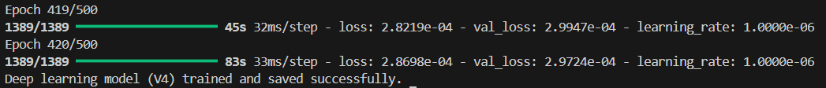

Fig (5.1) Training Results of the Neural Network (FPN)

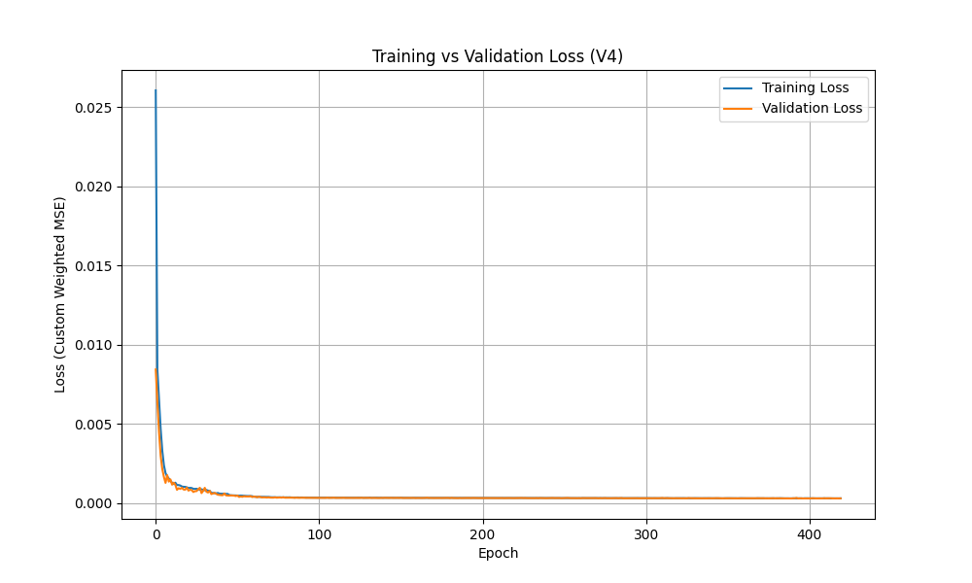

Fig (5.2) Training vs Validation Loss Visualization

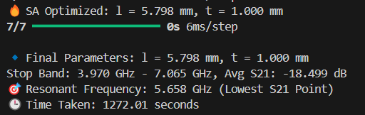

Fig (5.3) Results of the GA + SA Optimization

**Output:**

**Optimal FSS parameters**

🔹 Final Parameters: l = 5.798 mm, t = 1.000 mm

Stop Band: 3.970 GHz - 7.065 GHz, Avg S21: -18.499 dB

🎯 Resonant Frequency: 5.658 GHz (Lowest S21 Point)

**Output Plot:**

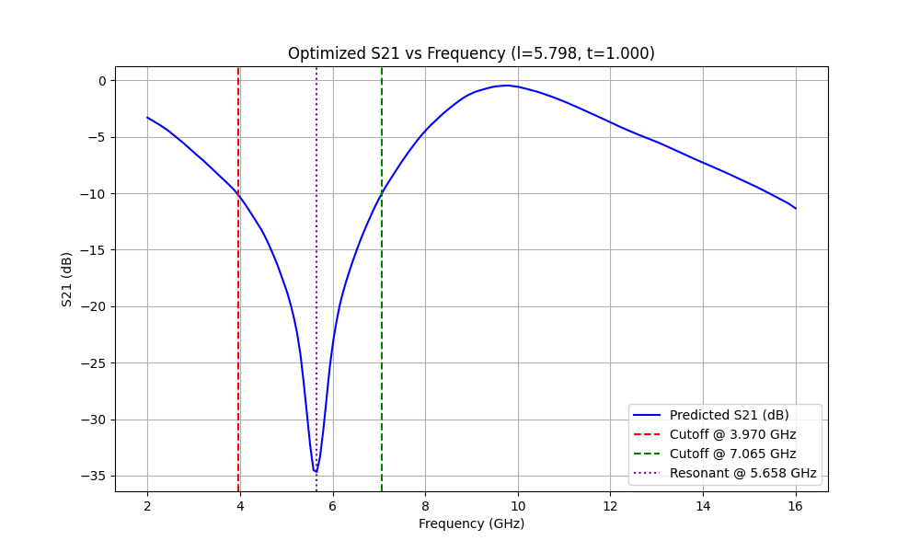

Fig (5.4) Visualization of S21 values Optimized Parameters by GA+SA

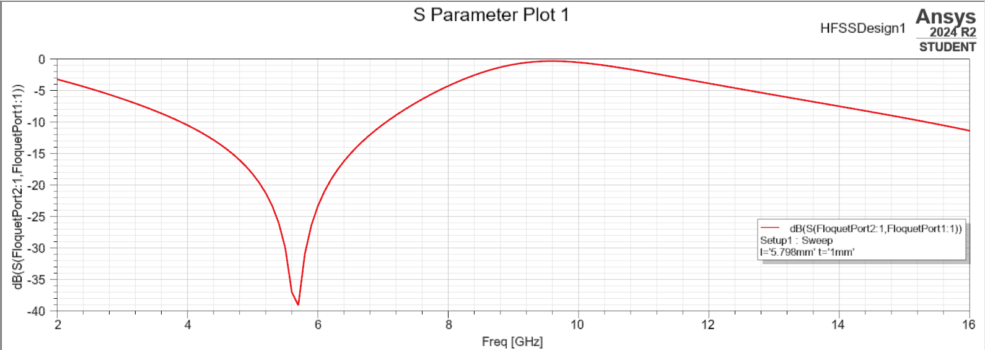

Fig (5.5) Simulated S21 Plot of Optimized Parameters

Additionally, optimization plots illustrate the convergence behaviour of the GA-SA hybrid technique. These visual tools help in understanding how design parameters influence performance and provide insights for further refinement.

**5.7 Summary**

This chapter presented the development and implementation of a neural network-based model for predicting the transmission behaviour of an FSS, optimized using a hybrid Genetic Algorithm and Simulated Annealing approach. The integrated model enables fast, accurate, and intelligent tuning of design parameters, supporting the overall goal of achieving efficient stopband filtering. This AI-powered methodology forms the backbone for the next phase of advanced FSS design and deployment.

**CHAPTER 6**

**PHASE 3: Enhanced Optimization with PSO+SA and NSGA-II+SA**

**6.1 Introduction**

In the final phase of the project, the focus shifts toward advanced hybrid optimization strategies to further enhance the performance and efficiency of Frequency Selective Surface (FSS) design. Two powerful combinations are explored:

1. Particle Swarm Optimization with Simulated Annealing (PSO+SA)
2. Non-dominated Sorting Genetic Algorithm II with Simulated Annealing (NSGA-II+SA)

These hybrid strategies are chosen to leverage the strengths of global search techniques (PSO and NSGA-II) and the local refinement capability of SA. Moreover, both approaches are integrated with the trained Forward Prediction Network (FPN), allowing real-time evaluation of design performance without repeatedly running computationally expensive EM simulations.

**6.2 Methodology Overview**

The methodology involves using the trained FPN to predict S21 values corresponding to different geometric configurations generated during optimization. The optimization goal is to identify FSS geometries that yield desirable frequency responses — particularly targeting:

* Maximum Bandwidth
* Minimum Insertion Loss

To accomplish this, each hybrid technique is implemented with the following sequence:

1. Generate initial candidate solutions using PSO or NSGA-II.
2. Use the FPN to evaluate the performance of each candidate.
3. Refine selected solutions with Simulated Annealing to avoid local optima.
4. Record and compare the optimized parameters and their corresponding frequency responses.

**Objective Function**

To guide the optimization process, a custom objective function was formulated to prioritize both the width and depth of the stopband. The function evaluates predicted S21 values generated by the trained Forward Prediction Network (FPN) for given parameter inputs. It identifies the stopband frequency range where S21 is below the desired threshold (e.g., -10 dB) and calculates the corresponding bandwidth f2 – f1 and average attenuation (avg_S21) within that range. The objective function returns a negative score computed as −(stopband width×(−avg_S21)1.5) ensuring that broader and deeper stopbands yield better (i.e., more negative) values. This formulation helps the optimization algorithms select parameter sets that maximize stopband effectiveness while penalizing configurations with weak or narrow rejection bands.

**6.3 Algorithm Descriptions**

**6.3.1 Particle Swarm Optimization (PSO)**

PSO is a population-based stochastic optimization technique inspired by the social behaviour of birds flocking or fish schooling. Each particle represents a potential solution and adjusts its position in the search space based on personal and global best experiences.

* Strengths: Fast convergence, simple implementation, effective for continuous parameter spaces.
* Limitation: May get trapped in local minima.

**6.3.2 Non-dominated Sorting Genetic Algorithm II (NSGA-II)**

NSGA-II is an evolutionary algorithm designed for solving multi-objective optimization problems. It works by evolving a population over generations using selection, crossover, and mutation operators while maintaining a diverse set of non-dominated solutions (Pareto front).

* Strengths: Excellent for handling conflicting objectives, maintains diversity through crowding distance.
* Limitation: Can be computationally expensive without surrogate models.

**6.3.3 Simulated Annealing (SA)**

SA is a probabilistic local search algorithm that mimics the annealing process of metals. It allows occasional acceptance of worse solutions to escape local minima, with a decreasing probability as the temperature lowers.

* Strengths: Effective in local refinement and escaping local traps.
* Role in Hybridization: Used after PSO/NSGA-II to fine-tune solutions.

**6.4 Working Process of Hybrid Techniques**

**6.4.1 PSO + SA Framework**

1. Initialization: A swarm of particles is initialized with random design parameter values (e.g., leg length, strip width).
2. Global Search: PSO iteratively updates the position of particles to explore the global solution space based on individual and global bests.
3. Prediction: Each particle’s position is evaluated using the FPN to predict S21 performance.
4. Local Refinement: SA is applied to the best-performing solutions from PSO to further refine them by exploring their neighbourhood.
5. Output: The best configuration with maximum bandwidth and minimum insertion loss is recorded.

**6.4.2 NSGA-II + SA Framework**

1. Initialization: A population of individuals is randomly generated, each encoding a set of FSS parameters.
2. Multi-objective Optimization: NSGA-II evolves the population based on Pareto dominance, focusing on maximizing bandwidth and minimizing insertion loss.
3. Surrogate Evaluation: The FPN model is used to evaluate frequency responses for each individual.
4. Refinement: SA is applied to selected individuals from the Pareto front to fine-tune solutions.
5. Pareto Set Generation: A refined Pareto-optimal set is obtained, offering designers a range of trade-off solutions.

**6.5 Results and Visualization**

The hybrid methods were evaluated using the trained FPN model to accelerate convergence. Key performance indicators include bandwidth improvement, insertion loss reduction, and time efficiency.

**6.5.1 PSO + SA Results**

* Achieved a configuration with broad bandwidth and low insertion loss in fewer iterations.
* The optimization was approximately 30% faster than conventional PSO-only methods.

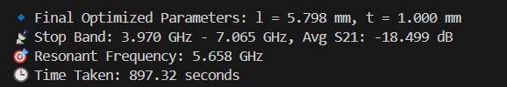

Fig (6.1) Results of the PSO + SA Optimization

**Output Plot:**

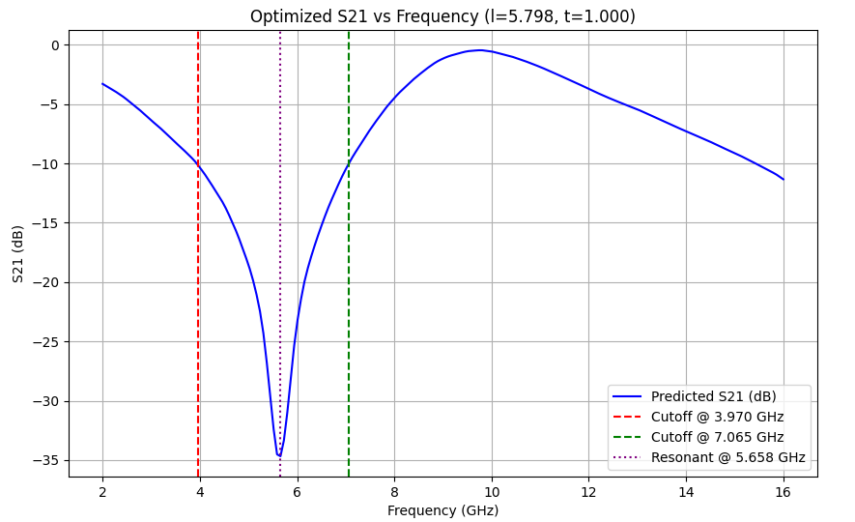

Fig (6.2) Visualization of S21 values Optimized Parameters by PSO+SA



Fig (6.3) Simulated S21 Plot of Optimized Parameters

**6.5.2 NSGA-II + SA Results**

* Generated a Pareto front showing trade-offs between bandwidth and insertion loss.
* Provided multiple optimized designs, allowing designers to choose based on performance priorities.



Fig (6.4) Results of the NSGA + SA Optimization

**Output Plot:**

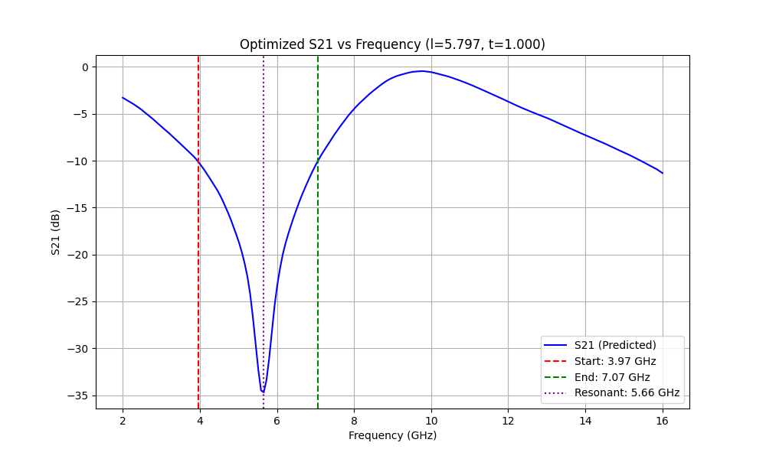

Fig (6.5) Visualization of S21 values Optimized Parameters by NSGA+SA



Fig (6.6) Simulated S21 Plot of Optimized Parameters

Table 6.1: Comparative Analysis of Hybrid Optimization Approaches for FSS Parameter Tuning

|  |  |  |  |  |  |
| --- | --- | --- | --- | --- | --- |
| Optimization Approach | Optimized Parameters (l, t) | Stop Band (GHz) | Average S21 (dB) | Resonant Frequency (GHz) | Time (seconds) |
| GA + SA | l = 5.798 mm  t = 1.000 mm | 3.970 – 7.065 | -18.499 | 5.658 | 1272.01 |
| NSGA-II + SA | l = 5.797 mm  t = 1.000 mm | 3.970 – 7.065 | -18.497 | 5.658 | 900.15 |
| PSO + SA | l = 5.798 mm  t = 1.000 mm | 3.970 – 7.065 | -18.499 | 5.658 | 897.32 |

The comparative analysis in Table 6.1 demonstrates that all hybrid optimization techniques achieved nearly identical performance in terms of stopband, average S21, and resonant frequency. However, the combination of Particle Swarm Optimization with Simulated Annealing exhibited the fastest convergence time, making it the most time-efficient approach among the evaluated methods.

**6.6 Summary**

This phase successfully demonstrated the potential of hybrid optimization frameworks in AI-assisted FSS design. The integration of global search (PSO/NSGA-II) with local refinement (SA) provided a balanced exploration-exploitation strategy. Additionally, the FPN model drastically reduced computational overhead by replacing EM simulations during optimization.

Key takeaways:

* PSO+SA offers rapid convergence and is suitable for single-objective fine-tuning.
* NSGA-II+SA is ideal for multi-objective problems, delivering diverse trade-off solutions.
* Both methods enhanced the adaptability and scalability of the AI-based FSS design framework.

These findings affirm the robustness of the hybrid approach in addressing complex, performance-driven electromagnetic design challenges.

**CHAPTER 7**

**SUMMARY AND CONCLUSION**

In this thesis, AI Based Design For FSS. This chapter summarizes the overall work done, conclusions obtained and the directions for the future work.

**7.1 SUMMARY**

The three phases in the development of the AI-based design for Frequency Selective Surfaces (FSS) provide a comprehensive, efficient, and accurate approach to optimize FSS structures for specific RF and microwave applications.

1. **Phase 1: Foundational FSS Design and Conceptualization**

The initial phase introduces the role of FSS in electromagnetic applications such as antennas, filters, and shielding. Traditional FSS design requires time-consuming full-wave simulations for each design iteration. This phase sets the groundwork by proposing the integration of a Forward Prediction Network (FPN) — a neural network model — with optimization algorithms to reduce simulation overhead. The FPN learns to predict the transmission coefficient (S21) given geometric parameters, while initial optimization efforts use evolutionary techniques like Genetic Algorithm (GA).

1. **Phase 2: Development of FPN with GA+SA Optimization**

This phase implements a robust FPN model trained on synthetic data derived from parametric simulations. It predicts the transmission coefficient curve for given inputs (e.g., lengths l, thickness t, and frequency). Genetic Algorithm (GA) is used to perform global exploration of the design space, followed by Simulated Annealing (SA) for local refinement. This GA+SA approach leverages the FPN’s prediction capability to avoid repetitive electromagnetic simulations, drastically improving efficiency while maintaining design accuracy.

1. **Phase 3: Enhanced Optimization with PSO+SA and NSGA-II+SA**

The final phase explores two advanced hybrid optimization strategies: PSO+SA and NSGA-II+SA. The PSO+SA combination uses swarm intelligence to rapidly converge on promising parameter regions, while SA fine-tunes the solution. NSGA-II introduces multi-objective optimization to handle trade-offs, such as maximizing bandwidth and minimizing insertion loss. Both approaches interact with the trained FPN for real-time evaluation of design performance. These hybrid strategies further improved design accuracy and reduced optimization time, highlighting the adaptability of the framework to various performance goals and FSS configurations.

**7.2 Conclusion**

The AI-based methodology integrating a Forward Prediction Network (FPN) with three hybrid optimization approaches—Genetic Algorithm + Simulated Annealing (GA+SA), Particle Swarm Optimization + Simulated Annealing (PSO+SA), and NSGA-II + Simulated Annealing (NSGA-II+SA)—provides a fast, accurate, and scalable framework for the design of Frequency Selective Surfaces (FSS).

By eliminating the need for repeated full-wave simulations, the trained FPN rapidly predicts S21 values, while the optimization algorithms efficiently explore the design space to identify optimal structural parameters. This combination dramatically reduces computational cost and time while maintaining high fidelity in transmission prediction.

The effectiveness of this multi-phase optimization strategy has been demonstrated in generating deep and wide stop bands at targeted frequency ranges. The approach holds strong potential for extending to broader RF and microwave applications where precision, speed, and adaptability are essential.

**7.3 DIRECTION FOR FUTURE WORK**

1. **Validation with Real-World Data**: Future work can involve the fabrication and testing of FSS prototypes based on optimized parameters. Comparing measured S21 responses with FPN predictions will validate the practical applicability of the model. Additionally, integrating partial full-wave simulation feedback with AI-driven predictions may enhance accuracy while maintaining computational efficiency.
2. **Advanced Optimization Techniques**: Further research can investigate the use of more advanced or hybrid metaheuristic algorithms, such as Differential Evolution, Adaptive NSGA-II, or Reinforcement Learning-based optimization. Multi-objective approaches can help balance competing goals like maximizing bandwidth while minimizing insertion loss.
3. **Material and Manufacturing Considerations**: To move closer to real-world deployment, future optimization can include parameters like dielectric constants, conductor loss, and fabrication tolerances. This will help ensure the designs remain robust under material variability and practical manufacturing constraints.
4. **Scalability and Real-Time Optimization**: Extending the model to handle large-scale FSS arrays or tunable designs in reconfigurable systems presents a promising direction. Embedding the trained models into real-time systems for adaptive filtering or beam steering could open new applications in smart RF and communication environments.

**REFERENCES**

1. **R. Cong, C. Zhang, N. Liu, K. Yang, X. Gao, and X. Sheng,** "A Novel Method for Frequency Selective Surface Design Using Deep Learning with Improved Particle Swarm Algorithm," *2022 IEEE the 9th International Symposium on Microwave, Antenna, Propagation and EMC Technologies for Wireless Communications (MAPE)*, 2022, pp. 374-379, doi: 10.1109/MAPE53743.2022.9935221.
2. **Z. Gu, D. Li, Y. Wu, Y. Fan, C. Yu, H. Chen, and E.-P. Li**, "A Solution to the Dilemma for FSS Inverse Design Using Generative Models," *IEEE Transactions on Antennas and Propagation*, vol. 71, no. 6, pp. 5100-5108, Jun. 2023, doi: 10.1109/TAP.2023.3266053.
3. **N. Calik, M. A. Belen, P. Mahouti, and S. Koziel**, "Accurate Modeling of Frequency Selective Surfaces Using Fully-Connected Regression Model With Automated Architecture Determination and Parameter Selection Based on Bayesian Optimization," *IEEE Access*, vol. 9, pp. 38396-38408, 2021, doi: 10.1109/ACCESS.2021.3063523.
4. **B. Dokmetas, S. S. Shinde and M. A. Belen,** "Artificial Intelligence Based Deep Learning Surrogate Model for Design Optimization of Microstrip Frequency Selective Surface," *2024 International Conference on Emerging Smart Computing and Informatics (ESCI)*, Pune, India, 2024, pp. 1-4, doi: 10.1109/ESCI59607.2024.10497238.
5. **Y. Xie, Y. Wang and Q. Wang**, "Design of Frequency Selective Surface using Residual Network," *2024 International Applied Computational Electromagnetics Society Symposium (ACES-China)*, Xi'an, China, 2024, pp. 1-3, doi: 10.1109/ACES-China62474.2024.10699652.
6. **Z. Gu, D. Li, Y. Fan, L. Zhang, Y. Liu and E. Li**, "Intelligent Design of Arbitrary Bandstop FSS Through Deep Learning and Genetic Algorithm," *2022 Asia-Pacific International Symposium on Electromagnetic Compatibility (APEMC)*, Beijing, China, 2022, pp. 649-651, doi: 10.1109/APEMC53576.2022.9888547.